Migration of SQL SERVER with POWERSHELL(DBA Tools)::

Migration with powershell sqldbatools can be done with START_DBAMIGRATION but for doing it component by component. Please find below commands::

**MIGRATE DATABASES:: COPY-DBADATABASE**

SYNTAX :: Copy-DbaDatabase -Source $scopource -Destination $dest -BackupRestore -UseLastBackups -AllDatabases

**MIGRATE LOGINS :: COPY-SQLLOGIN**

SYNTAX :: Copy-DBaLogin -Source tul1cipxdb13 -Destination tul1mdpdwds13



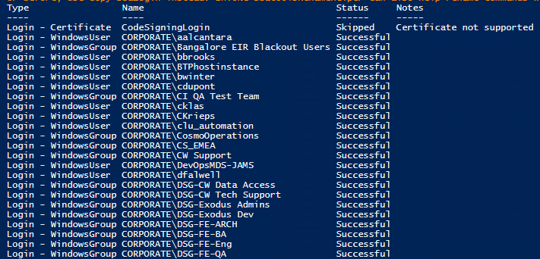

**COPY-DBAAGENTSERVER:: It copies jobs, alerts,schedules,category**

SYNTAX:: Copy-DbaAgentServer -Source $source -Destination $dest

**COPY-DBAAGENTJOBCATEGORY:: Covered in above command, can be run separately**

SYNTAX::Copy-DbaAgentJobCategory -Source $source -Destination $dest

**COPY-DBAAGENTJOB::**

SYNTAX::Copy-DbaAgentJob -Source $source -Destination $dest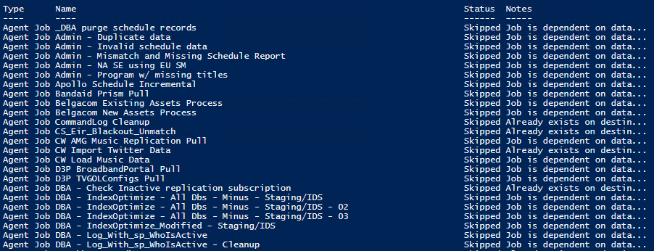

**COPY-DBAAGENTOPERATOR:: Covered in copy-dbaagentserver, can be run separately**

SYNTAX:: Copy-DbaAgentOperator -Source $source -Destination $dest

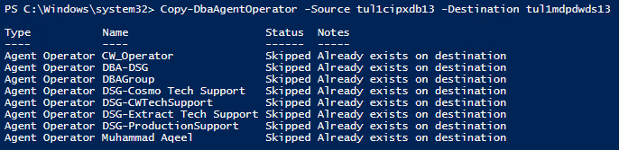

**PROXY ACCOUNT:: Copy-DbaAgentProxy**

SYNTAX:: Copy-DbaAgentProxy -Source $source -Destination $dest

**CREDENTIALS :: Copy-DbaCredential**

SYNTAX:: Copy-DbaCredential -Source $source -Destination $dest

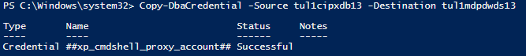

**CUSTOM ERRORS :: Copy-DbaCustomError**

SYNTAX:: Copy-DbaCustomError-Source $source -Destination $dest

**SP CONFIGURE :: Copy-DbaSpConfigure**

SYNTAX:: Copy-DbaSpConfigure-Source $source -Destination $dest

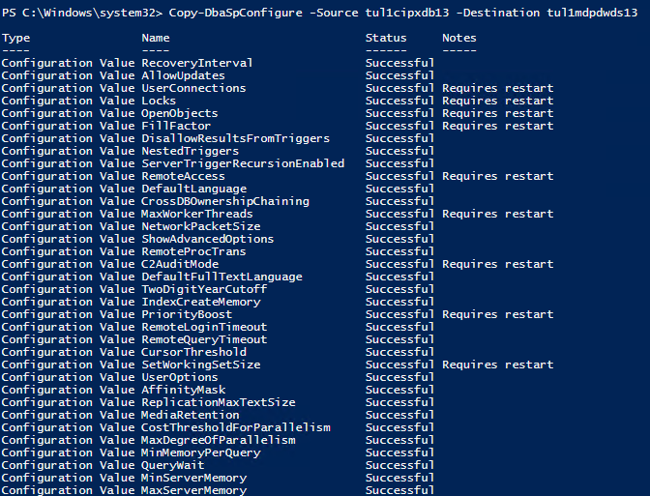

**DB MAIL :: Copy-DbaDBMail**

SYNTAX:: Copy-DbaDbMail -Source $source -Destination $dest

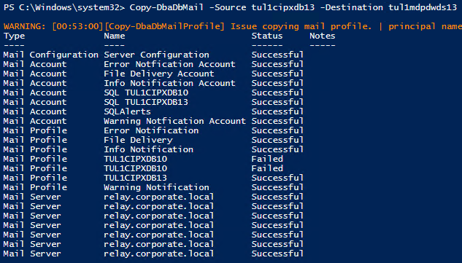

**LINKED SERVER:: Copy-DbaLinkedServer**

Syntax:: Copy-DbaLinkedServer -Source $source -Destination $dest -upgradesqlclient

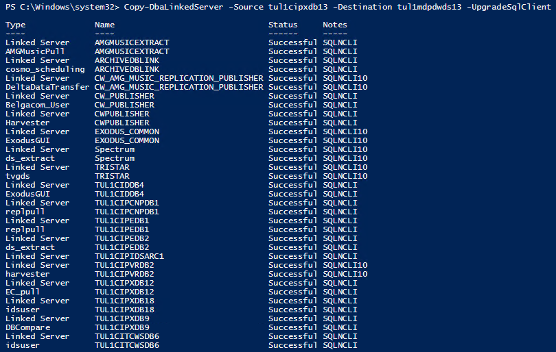

**SYSTEM DATABASE USER OBJECTS:: Copy-DbaSysdbUserObject**

Syntax:: Copy-DbaSysDbUserObject -Source $source -Destination $dest

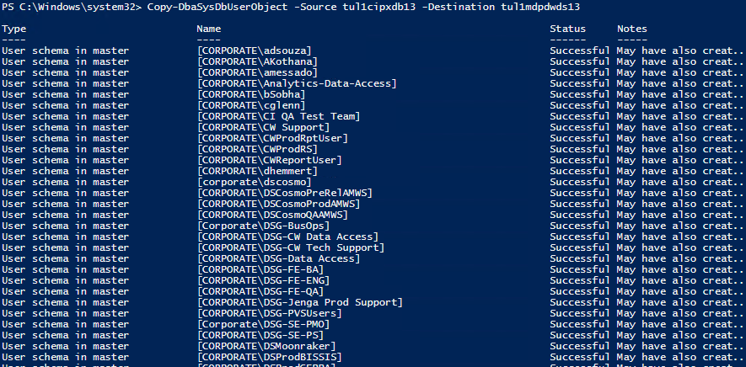

**ASSEMBLY::**

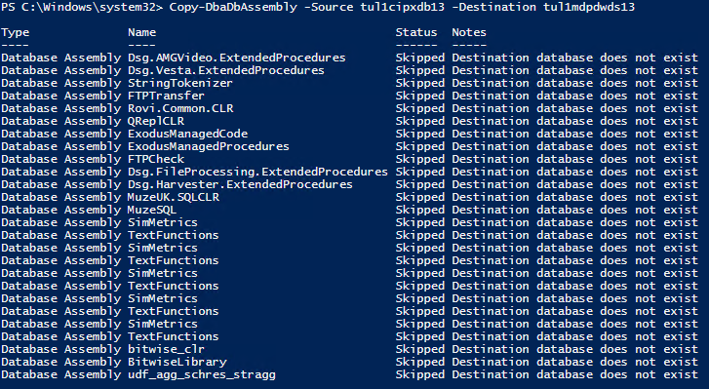

**Policy Based Management::**

